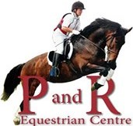

**P and R Equestrian Centre**

**Horse Riders Code of Conduct**

* I understand that riding at any standard has inherent risk and that all horses may react unpredictably on occasions.
* I may fall off and could be injured. I accept that risk.
* I understand that instructions are given for my safety and agree to follow instructions given to me by staff and instructors of the riding school.
* I reserve the right not to ride a horse allocated to me and may request a change of instructor.
* I understand that wearing an appropriate riding hat and body protector may reduce the severity of an injury should an accident happen and agree that I will always wear a riding hat whilst riding, leading and grooming horses at the riding school. I understand it is my choice whether or not I wear a body protector. Barrowing P and R Equestrian Centres Hats and Boots are at your own risk
* I understand that the riding school will make decisions based on information I give them and agree to always be honest and volunteer information about:
  + my abilities and riding experience
  + any previous riding accidents
  + any medical condition(s) which may affect my ability to ride
* I understand that children are at particular risk around horses and agree that I will keep any children that I am responsible for, under close supervision when they are not being instructed by the riding school.
* I understand that the riding school may refuse my request to ride for safety or operational reasons.
* I understand that competing carries enhanced risk over and above general riding and agree that if I chose to participate in any competition or event, it is up to me to ensure that I have the experience and ability to ride the course including any jumps which form part of it. If I am in any doubt, I will use my judgment and experience and not enter.
* I understand that that any horse activity im booked into is cancelled with less than 24 hours notice will incur a full fee, and that if I cancel more than three times, there will be a requirement for a £10 non refundable deposit to be paid on future bookings.
* Head cams will be used on all sessions.
* I do/do not* give permission for my photograph/ video footage to be used for promotional purposes by P and R Equestrian Centre. write your answer and sign.

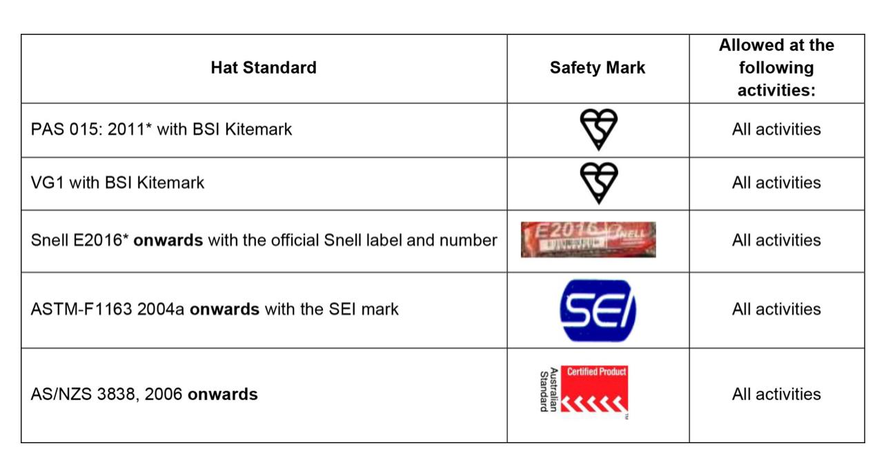

Only the new hat standard can be worn whilst riding in P and R Equestrian Centre.

Signed: ……………………………….......... Print Name: ………………………....... Date: ……………….

 **Confidential - Please complete all sections below:**

**P and R Equestrian Centre**

**Horse Riders Registration Form**

First Name: __________________ Surname: _______________________ Address: _________________________

____________________________________________________________________ Postcode: ________________

Tel: (home)___________________ Tel: (mobile) ____________________ Email: ____________________________

Occupation: ____________________ Date of Birth: _____________ Age: _____ Weight: ______ Height: ________

Have you, or the rider you are signing for, ever suffered a serious injury or discomfort while riding, or been advised not to ride? Yes / No (Delete as applicable). If YES, please describe: _____________________________________

Please detail any disability or medical conditions that may affect your ability to ride. This may include but not be limited to any back problems and any condition, which can affect balance or cause blackouts/loss of consciousness/fitting etc. ___________________________________________________________________­­­­­­­­­___________________________

**Emergency Contact**

Contact name and relationship: ………………………………… Tel: ………………………….

Complete beginner Beginner Novice Intermediate Advanced

How many times have you/rider ridden in the past 12 months? None Under 12 12-40 40+

What do you believe your or the rider’s capability to ride on a horse or pony to be?

Riding at Walk Trotting with stirrups Trotting without stirrups Cantering Hacking

Riding over jumps up to 0.5m (18”) Riding over jumps 0.75m (30”)  Riding over cross country jumps 

I confirm that to the best of my knowledge all of the above details are correct.

I have read the Horse Riders Code of Conduct overleaf. I understand that riding at any standard has inherent risk that I may fall off and could be injured. I accept that risk and agree that the riding school will not be liable for any injury or damage to property unless it is caused by their negligence.

Where I am signing on behalf of a minor, I have explained the Riders Code of Conduct to the minor and we both accept the risk and agree that the riding school will not be liable for injury or damage to property unless it is caused by their negligence.

I have read and understand the lesson booking and cancellation policy and agree to abide by it at all times.

Data Protection Act 1998: Statement: I understand that the information I have given will be held in accordance with the Data Protection Act 1998 but may be made available to insurers and other concerned parties in the event of any injury or incident.

**Signature**: ……………………………………………… **Print Name**: …………….……..…………………. **Date:**  …………………..

If signed on behalf of a minor: **Riders Name:** …………………………………….. **Relationship to minor:** ………………………….

**To be completed by instructor/Supervisor on behalf of the Equestrian Establishment**

This client has been assessed and our judgement on their capabilities is as follows:

Complete beginner (lead rein/lunge) Beginner (beginning walk/trot independently)

Novice(walk,trot,canter independently) Intermediate (jumping, Stage 1) Advanced (Stage 2 equivalent and above)

R

**Riders name: ………………………………………**

**Assessment lesson content:** Walk Trot Canter W/O Stirrups Jump Lateral



Horse used: …………………………………Lesson Type: ………………… Date: ………………… Time: ………………

Signature: ………………………………………. Print Name: ………………………………..